INCOMPLETE IDEAS:

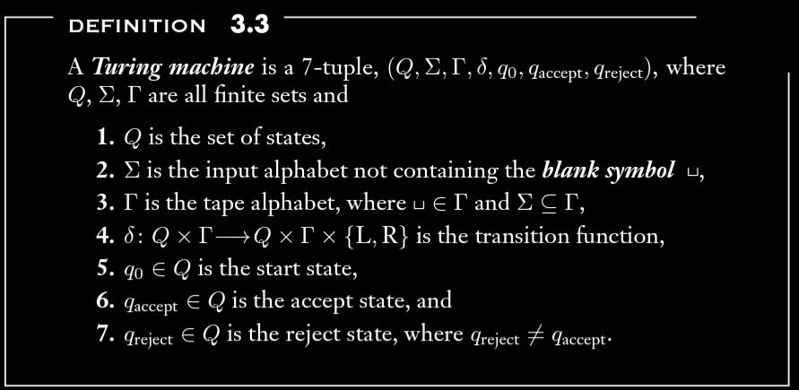

Create a template data type A (number, letter, color, …)

Create a template data type B

Create a language A that is Turing recognizable

Create a language B that is Turing recognizable

Allow |A|=|B|

Zip each corresponding phrase of language together as list of pairs